Question 1
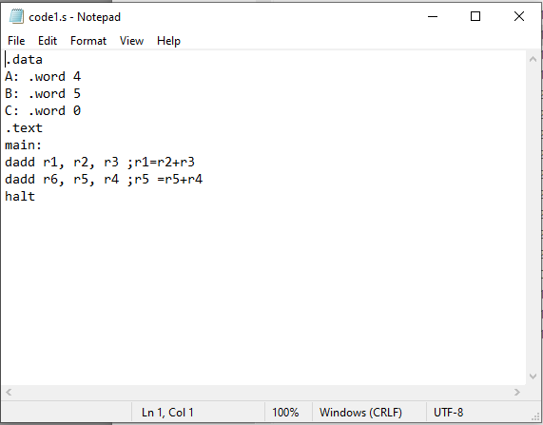
a)
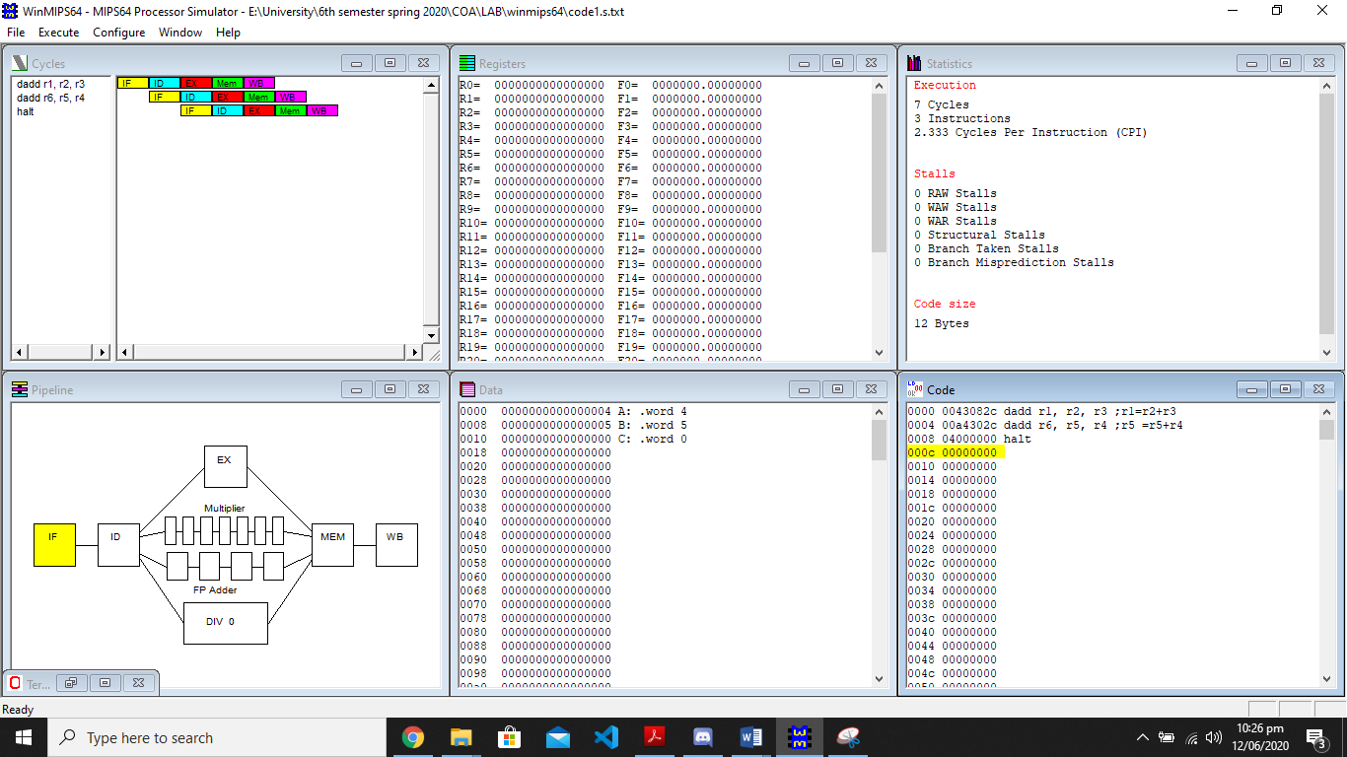
b)
Execution time on non-pipelined computer is given as: tnp = nk
where k=5 and n=3
Tnp=5x3=15s
c)
Instruction Throughput (Non-Pipelined Execution) =
No. of instructions executed per unit time = IPC = n / tnp = 3/15=0.2
d)
Execution time on pipelined computer is given as: tp = (n+k-1)
Tp=(3+5-1)=7s
e)
Speedup = tnp / tp
=15/7 =2.14
f)
Instruction Throughput (Pipelined Execution) =
No. of instructions executed per unit time = IPC = n / tp
=3/7 =0.428
g)
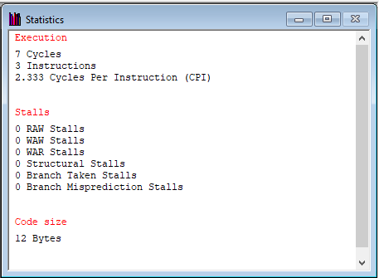

Question 2
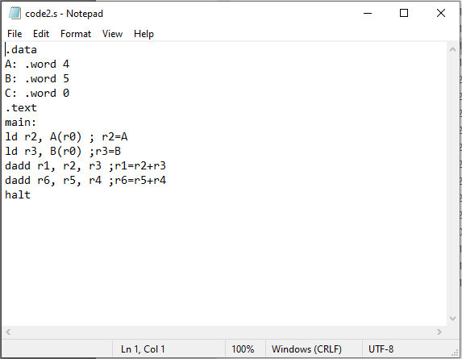

a)
RAW hazard found which is read after write. Hazard occurs when reading is done first and then writing.

b)
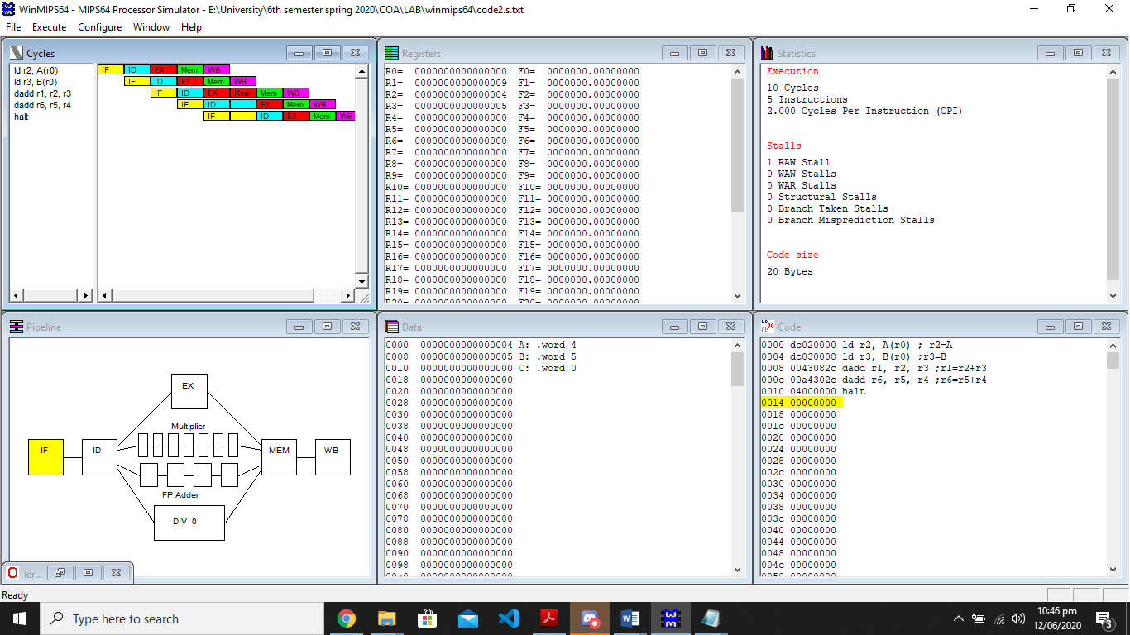

Question 3
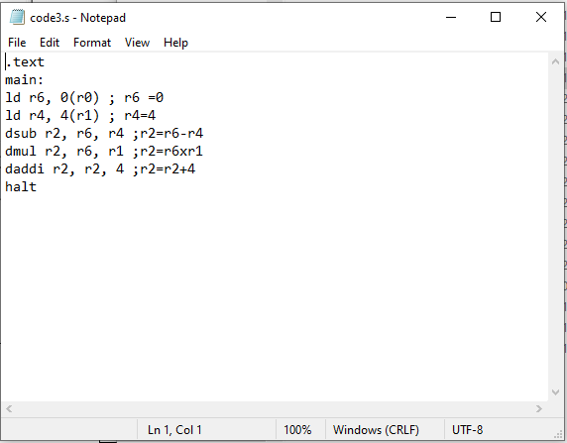
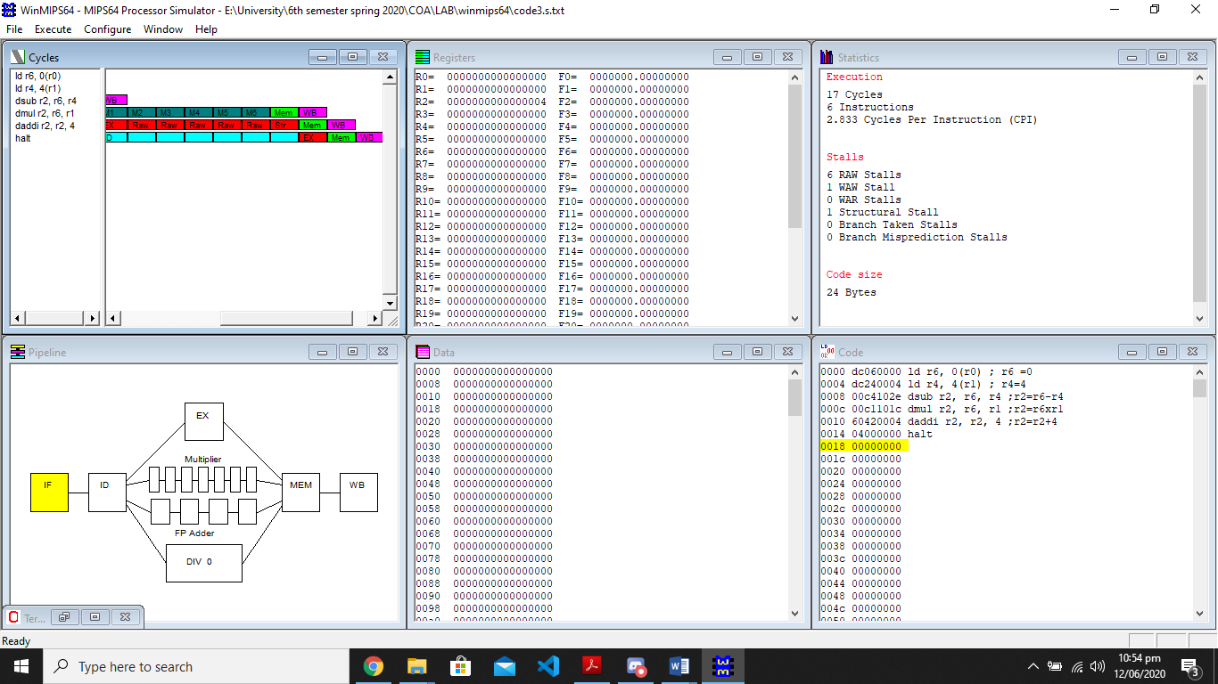
a)
17
b)
2.833
c)
RAW: reading is done first and then writing.
WAW: first instruction writes before the second write.
Structural stall: They arise from resource conflicts when the hardware cannot support all possible combinations of instructions in simultaneous overlapped execution.

